**Instancing in WCF**



**Rameshkartik. RS**

**Table of Contents**

What is InstanceContextMode 3

PerSession 3

PerCall 6

Single 8

Attachment 10

Summary 10

**WHAT’s IN THIS ARTicle?**

* What is InstanceContextMode?
* PerSession
* PerCall
* Single
* Attachment
* Summary

# What is InstanceContextMode

InstanceContextMode determines the client proxy to communicate with the server in the following manners

* Using one and the same instance of the server object (PerSession)
* Using the new instance that is created on, every method call(PerCall)
* Using the single instance that is created for all the clients(Single)

What exactly the benefit you will get on using each InstanceContextMode? In which situation each InstanceContextMode should be used? We will discuss all the InstanceContextMode in detail

# PerSession

ONE SERVER INSTANCE PER CLIENT SESSION

-Means the client proxy communicates with one and same server instance till the session times out. In other words server object resides on the server as long as session times out(Default 10 minutes).

Advantage – The main advantage of Per session is that values which have been set are retained in the server side without any additional measures.

Disadvantage – scalability is the main disadvantage here, because every active session takes memory in the server regardless of the client currently requires or not.

Persession requires you to use a protocol which supports session. For example, you can use nettcpbinding with the connection oriented protocol TCP which allows the server to allocate the incoming message to the correct server object. The basichttpbinding is unsuitable because the transfer protocol HTTP is connectionless. You can also enforce the service to use the right binding by using the keyword SessionMode.Required in the service contract attribute.

DeclarationSession.png

The above is the declaration of InstanceContextMode->Session. You need to use the service behavior attribute at the top of the service implementation class.

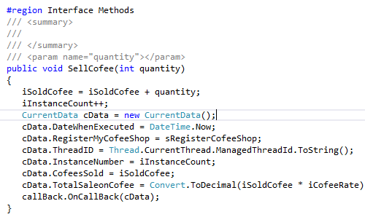

In the attached source code ,if you see the service interface method the iInstanceCount will be used. It is just used to hold the number of times this method has been executed.As I told you earlier, the Persession actually creates one server instance per session client,and the information will be retained in the server till the session expires.In our case the iInstanceCount will be incremented on every method call from client proxy.And the below snapshot is the output of the program

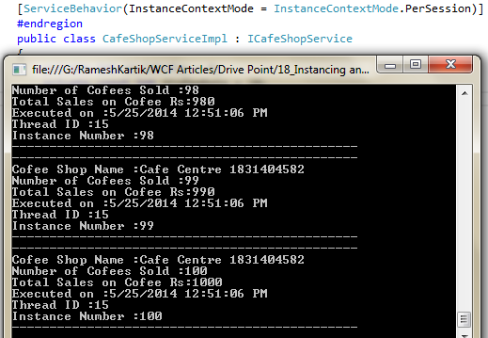

You can find that information will be maintained in the service. For further details please refer the attached source code.

# 

# PerCall

ONE SERVER INSTANCE PER METHOD CALL

-Means the client proxy communicates with the new service instance, which is created on, every method call from the client proxy. Yes, on every server method invocation from the client proxy the new instances will be created,as soon as the method is processed the new instance will be released again. If the service object implements the IDisposable interface, the Dispose method is called automatically after the result is sent to the proxy. This is extremely scalable since the object is released on, every method call,Also no need to worry about threading problems. But the main drawback here is we cannot able to maintain the information in the server side.

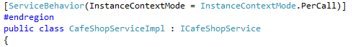

# The above one is declaration of InstanceMode->Percall. You need to use the service behavior attribute at the top of the service implementation class.



In the attached source code ,if you see the service interface method the iInstanceCount will be used. It is just used to hold the number of times this method has been executed.As I told you earlier, the PerCall actually creates one server instance per method call,so the information will not be retained on the server. In our case the iInstanceCount will be incremented on, every method call from client proxy and it will be disposed after the method call. And the below snapshot is the output of the program

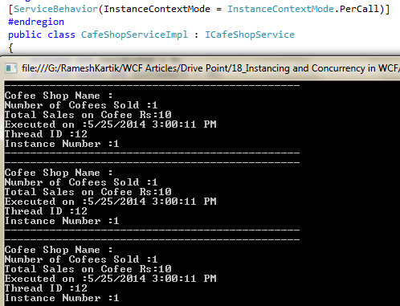

Refer the attached code for the further details

# Single

ONE SERVER INSTANCE FOR ALL THE CLIENTS

As the name suggests one server instance that is created will be for all the clients whoever connecting the server. Often we will come across the situation of creating global instances for all the clients,For that InstanceMode.Single would be very useful. The service instance created to serve for client 1 , will also used to serve the clients 2 and 3.

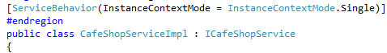

Above one is the declaration for the InstanceMode->Single.

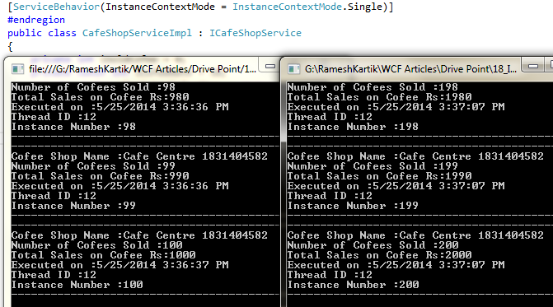

As I told you earlier the global server instance, will be created for all the clients. If you notice the above output you can find that Instance number will be shared across all the clients. If you run the second client the Instancenumber value will be incremented from the 100 where the client1 has finished the process. You can refer the attached source code for further details

# Attachment

Refer the source code attachment for further details

# Summary

|  |  |
| --- | --- |
| **PerSession** | One Server instance on every client session |
| **PerCall** | One Server instance on every method call |
| **Single** | One Server instance for all the clients |